Problem:

Python Script to fetch the zip code on basis of user input of Walmart store number.

Solution:

Currently the script is taking the input as Walmart store number.

As per the Walmart store finder website. By using the GET response on the website with the store number. We can fetch HTML website for the store number in case of success and a JSON object in case of failure.

The response is 200 in both cases.So it is handled by the tags.

I am using BeautifulSoup package to crawl the website and fetch the postal code available on the website for the store number provided.

*import* requests  
*from* bs4 *import* BeautifulSoup  
  
*def* zipCode(*storeNumber*):  
 url='<https://www.walmart.com/store/>' + *storeNumber* source_code=requests.get(url)  
 plain_text=source_code.text  
 *if not* plain_text.endswith("</html>"):  
 print("This Walmart store number does not exists.")  
 *else*:  
 soup = BeautifulSoup(plain_text, "lxml")  
 # print(soup)  
 *for* link *in* soup.findAll('span', itemprop="postalCode"):  
 postalcode = link.string  
 *if* str(postalcode) != "None":  
 print("Zipcode of walmart store number %s is : " %*storeNumber*+postalcode)  
  
  
storeNumber=input("Enter the Walmart Store Number: ")  
*if* storeNumber.isdigit():  
 zipCode(storeNumber)  
*else*:  
 print("Value not a valid Walmart code.")

**Test Scenarios:**

1. **User enters the valid Store number.**

**Input: 1234**

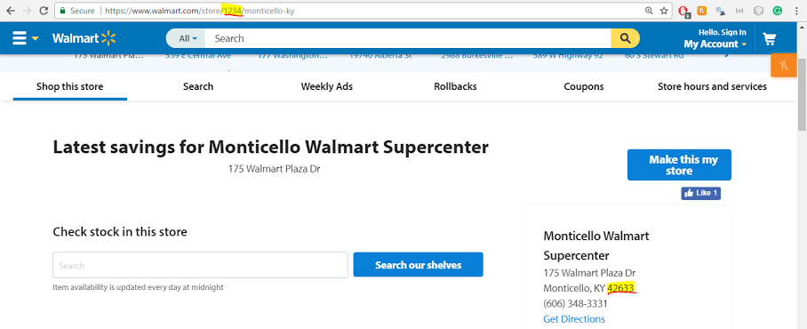

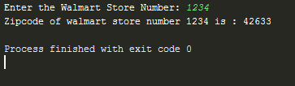

**Result:** Success and it will return the Zip code for that Store.

1. **User enters the invalid Store Number (i.e. anything apart from digits)**

C:\Users\Ankur\AppData\Local\Microsoft\Windows\INetCache\Content.Word\unnamed (2).png

C:\Users\Ankur\AppData\Local\Microsoft\Windows\INetCache\Content.Word\unnamed (4).png

C:\Users\Ankur\AppData\Local\Microsoft\Windows\INetCache\Content.Word\unnamed (3).png

**Result:** It will return the Error message of “*Value not a valid Walmart code.*”

1. **User enters a Store Number which doesn’t exists.**

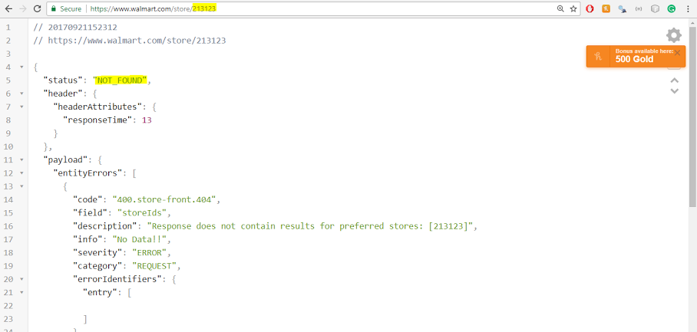

C:\Users\Ankur\AppData\Local\Microsoft\Windows\INetCache\Content.Word\unnamed (5).png

**Result:** It will return the Error Message of “*This Walmart store number does not exist”*